**Supplementary Information - 3**

**Two-stage Adaptive Modelling Framework for Long-term Monthly Operation of a Multi-purpose Reservoir for Regulating Environmental Flows**

**Ruby Jose1and Srinivasan K2**

1Former Research Scholar, 2Professor (Retd.), Department of Civil Engineering, Indian Institute of Technology Madras, Chennai – 600036.

Corresponding author: Ruby Jose. J ([rubyphdwork@gmail.com](mailto:rubyphdwork@gmail.com))

Address: Department of Civil Engineering, IIT Madras, Chennai 600036, India.

**Model validation – case example: Hemavathy Reservoir**

The main purpose of this reservoir is to supply water for irrigation through three canals taking off from the dam, commanding a total irrigated area of about 400,000 hectares. Nearly 95% of the flows into the reservoir are received during the period June-November. The gross storage capacity is 1050.63 Million m3 and the live storage capacity is of 926.82 Million m3. The location map of the study region is shown in Fig. S- 3.1.

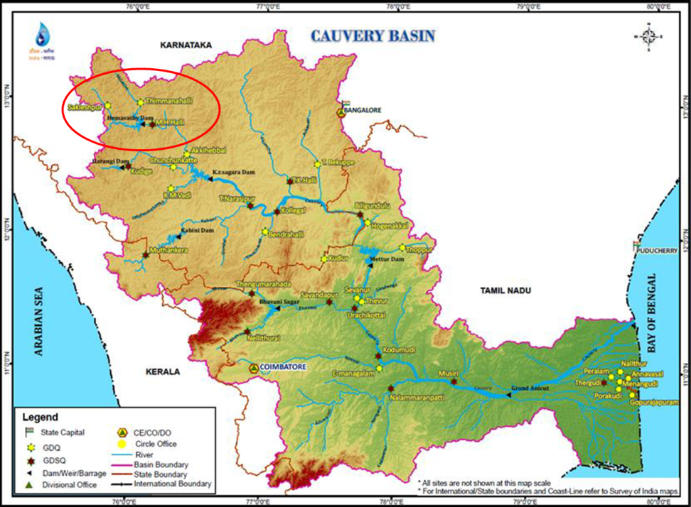

Fig. S- 3.1: Location Map of Hemavathy reservoir in Cauvery River Basin (Source: Operation and Maintenance Manual for Hemavathy Dam State of Karnataka)

The monthly Irrigation demands adopted in this study and the mean monthly flows into the reservoir are presented in Table S- 3.1. The optimal monthly E-flow targets at the reservoir are derived as a fraction of mean monthly flows (MMF) corresponding to the three hydrologic year types (dry, normal and wet). For the seven months (June-December), the E-flow targets are considered as decision variables (expressed as a fraction of the respective MMF) while the same for the remaining five low flow months are fixed as the respective MMF itself (Table S- 3.1). The HA in both the stages of the proposed two-stage adaptive multi-objective P-S-O framework is estimated using PCA-selected set of indicators chosen from the 32 Indicators of Hydrologic Alteration (IHA), by employing HCA. The five PCA-selected indicators are: annual maxima of 30-day means, monthly median of October, Julian date of each annual 1-day maximum, Number of low flow pulses within each water year and Median duration of low flow pulses (days).

**Table S- 3.1: Mean monthly inflows and monthly Irrigation target demands (×106m3)**

|  |  |  |  |  |  |  |  |  |  |  |  |  |
| --- | --- | --- | --- | --- | --- | --- | --- | --- | --- | --- | --- | --- |
|  | *Jun* | *Jul* | *Aug* | *Sep* | *Oct* | *Nov* | *Dec* | *Jan* | *Feb* | *Mar* | *Apr* | *May* |
| Mean Monthly  Inflow | 195 | 639 | 649 | 326 | 238 | 118 | 48 | 16 | 9 | 9 | 7 | 16 |
| Irrigation Target Demand | 4 | 32 | 242 | 283 | 281 | 213 | 185 | 59 | 16 | 20 | 18 | 13 |

**Deriving optimal monthly E-flow targets from the single-stage model**

The optimal monthly E-flow targets corresponding to the possible range of HA-HCA (HA values estimated using Histogram Comparison Approach) values are derived using the single-stage multi-objective model (IMHA-HCA). The Pareto-optimal front of IMHA-HCA, shown in Fig. 3, covers a wide range of HA-HCA values (30.58% to 48.24%), as against a range of Irrigation MSI from 5.67% to 11.18%.

However, as per the low-alteration category proposed by Richter et al. (1998), The P-O solution with HA-HCA values nearest to the low-alteration category (HA-HCA-32.96) is identified and carried forward to stage-2. The optimal monthly E-flow targets of the selected P-O solution derived from stage-1 are presented in Table S- 3.2.

**Table S- 3.2: Optimal monthly E-flow targets of dry, normal and wet years for the selected P-O solution of IMHA-HCA**

|  |  |  |  |  |  |  |  |  |  |  |  |  |  |  |  |
| --- | --- | --- | --- | --- | --- | --- | --- | --- | --- | --- | --- | --- | --- | --- | --- |
| Sol. | Irr  MSI  (%) | HA-HCA (%) | Year type | Optimal monthly E-flow targets (×106m3) | | | | | | | | | | | |
| J | J | A | S | O | N | D | J | F | M | A | M |
| IMHA-HCA-sol-1 | 8.41 | 32.96 | D | 58 | 192 | 195 | 98 | 71 | 35 | 14 | 16 | 9 | 9 | 7 | 16 |
| N | 59 | 192 | 513 | 99 | 83 | 65 | 39 | 16 | 9 | 9 | 7 | 16 |
| W | 59 | 273 | 281 | 98 | 71 | 37 | 40 | 16 | 9 | 9 | 7 | 16 |

**Performance trade-off between Irrigation MSI and E-flow MSI**

The stage-2 of the two-stage model IMEM is run for each of the selected P-O solution (HA-HCA value 32.96%) obtained from stage-1 by transferring the respective monthly E-flow targets, with the intent to determine the optimal reservoir releases that would achieve a good trade-off between Irrigation MSI and E-flow MSI. The proposed two-stage P-S-O framework is referred to as IMEM-HCA and the two model run mentioned above are denoted as IMEM-HCA-32.96, which correspond to the limiting HA-HCA values 32.96%, of the HA constraint in stage-2.

Both the P-O fronts are presented in Fig. 5 of the manuscript. To demonstrate the effectiveness of the trade-off between the two conflicting objective functions, two P-O solutions (IMEM-HCA-32.96-sol-1 and IMEM-HCA-32.96-sol-2) are selected: one solution that offers a good trade-off between Irrigation MSI and E-flow MSI; and another with lower E-flow MSI (Fig. 5b). The deficit statistics of releases towards Irrigation and E-flows for both the single-stage and the two-stage models are presented in Table S- 3.3 in terms of severe, less severe and zero deficits, adopting similar thresholds as in the Bhadra river-reservoir system.

For IMHA-HCA-32.96 and the two solutions selected from the compromise zone of IMEM-HCA-32.96, the number of deficit periods (NP) and the respective sum of the squared normalized E-flow/Irrigation deficits (SSND) according to the above-said categorization are presented in Table 5.

**Table S- 3.3: Deficit statistics of releases towards Irrigation and E-flows pertaining to IMHA-HCA-32.96 and two selected solutions from IMEM-HCA-32.96**

|  |  |  |  |  |  |
| --- | --- | --- | --- | --- | --- |
| **Irrigation deficit statistics** | | | | | |
| **Model Run** | **Attributes** | **Severe** | **Less Severe** | **Zero Deficit** | **Irrigation MSI** |
| **IMHA-HCA-32.96** | NP | 120 | 109 | 227 | 8.41 |
| SSND | 35.39 | 2.89 | 0 |
| IMEM-HCA-32.96-sol-1 | NP | 78 | 80 | 298 | 5.16 |
| SSND | 20.08 | 3.39 | 0 |
| IMEM-HCA-32.96-sol-2 | NP | 108 | 95 | 253 | 6.69 |
| SSND | 26.97 | 3.48 | 0 |
| **E-flows deficit statistics** | | | | | |
| **Model Run** | **Attributes** | **Severe** | **Less Severe** | **Zero Deficit** | **E-flow MSI** |
| **IMHA-HCA-32.96** | NP | 71 | 170 | 215 | 4.82 |
| SSND | 12.74 | 9.17 | 0 |
| IMEM-HCA-32.96-sol-1 | NP | 26 | 129 | 301 | 5.35 |
| SSND | 20.75 | 3.55 | 0 |
| IMEM-HCA-32.96-sol-2 | NP | 23 | 114 | 319 | 4.82 |
| SSND | 20.07 | 1.75 | 0 |

*NP-Number of periods (out of 456); SSND-sum of squared normalized deficits.

It is observed from Table S- 3.3 that although the number of periods resulting in severe deficits of E-flows is lesser for IMEM-HCA-32.96 than IMHA-HCA-32.96, the magnitude indicated by the sum of squared normalized deficits (SSND) is significantly higher. Contrarily, the number of less severe deficit periods and the corresponding magnitude denoted by SSND of E-flows are much lower in case of IMEM-HCA-32.96 than IMHA-HCA-32.96. Overall, only a slight increase in E-flow MSI is noted in case of IMEM-HCA-32.96-sol-1 over IMHA-HCA-32.96, as the magnitude of SSND of severe deficits is well moderated by that of less severe deficits. While in case of IMEM-HCA-32.96-sol-2, the severe E-flow deficits are entirely compensated by the less severe E-flow deficits resulting in an E-flow MSI same as that of IMHA-HCA-32.96 but for a lesser Irrigation MSI (6.69%).

On the other hand, both the number of periods as well as the magnitude indicated by the sum of squared normalized deficits of severe Irrigation deficits of IMEM-HCA-32.96 is much lesser than those of IMHA-HCA-32.96. This has led to the substantial decrease in the Irrigation MSI for the proposed model IMEM than the single-stage model IMHA, in case of both the solutions selected.

Thus IMEM-HCA-32.96 is found to outperform IMHA-HCA-32.96 in meeting the Irrigation targets, while accomplishing a reasonable performance in satisfying the E-flow target demands (derived in single-stage model). This can be attributed to the optimal trade-off between the two conflicting objective functions, namely, minimizing Irrigation MSI and minimizing E-flow MSI.